Data Factory – Creating Linked Services

Click on Connections, click ‘New’ under Linked Services

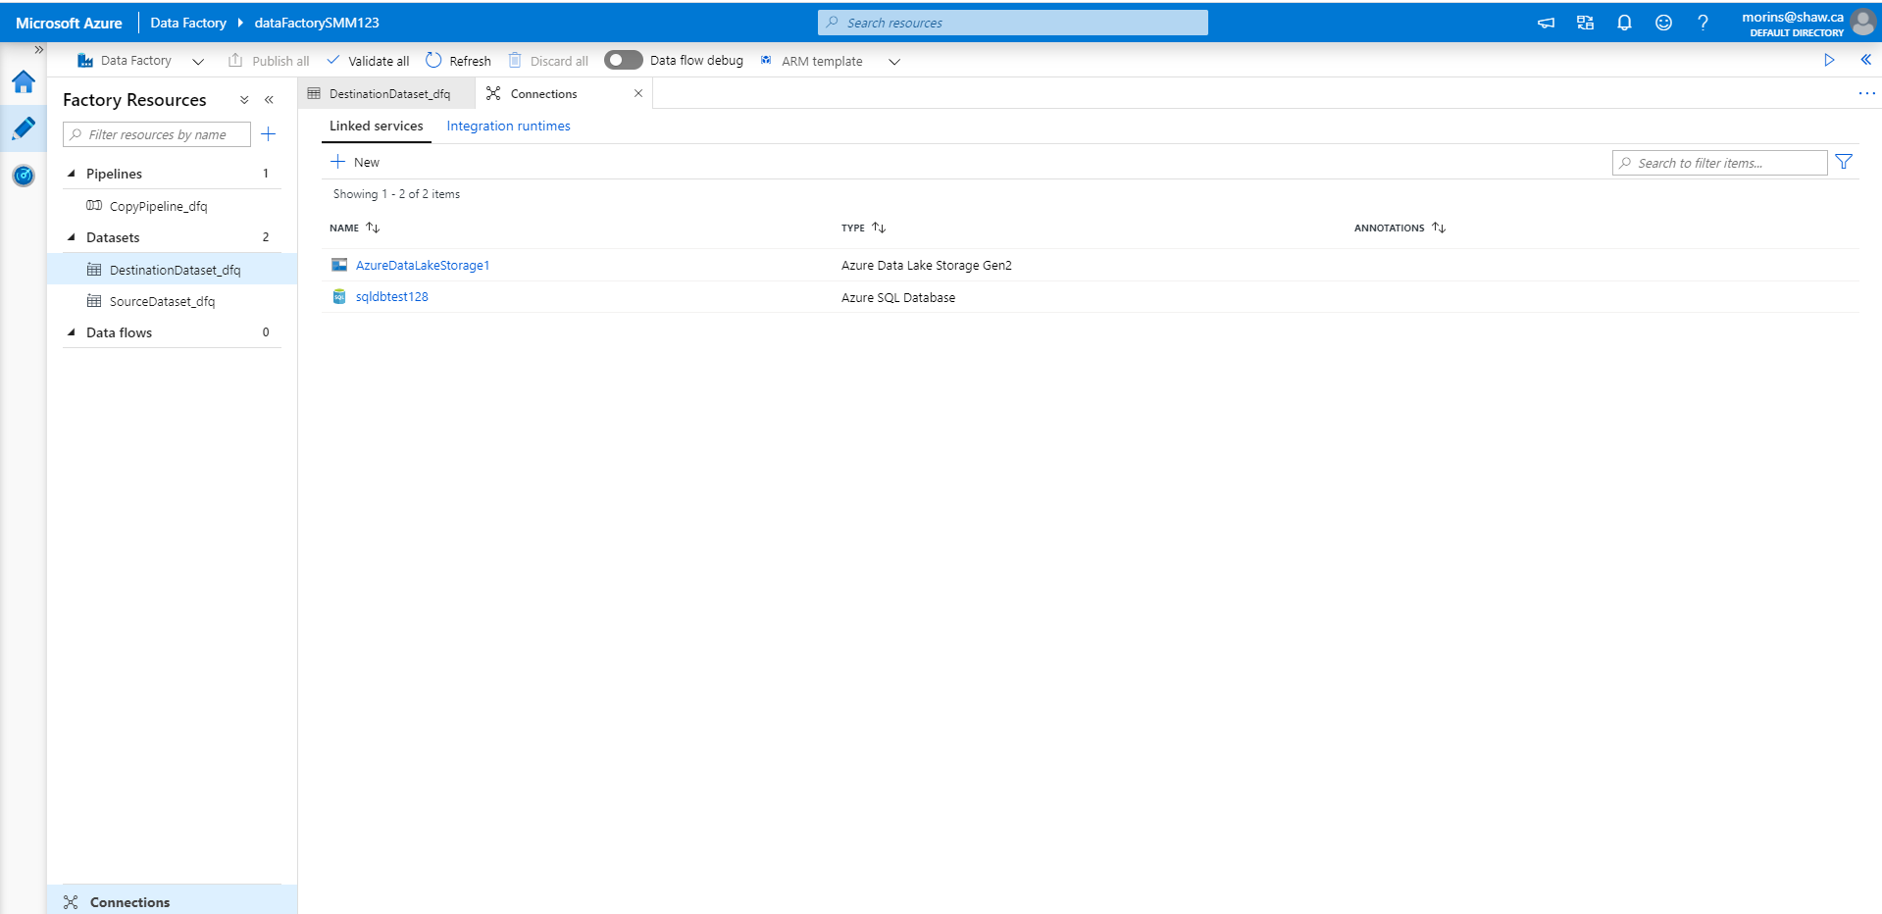

Select Azure SQL DB:

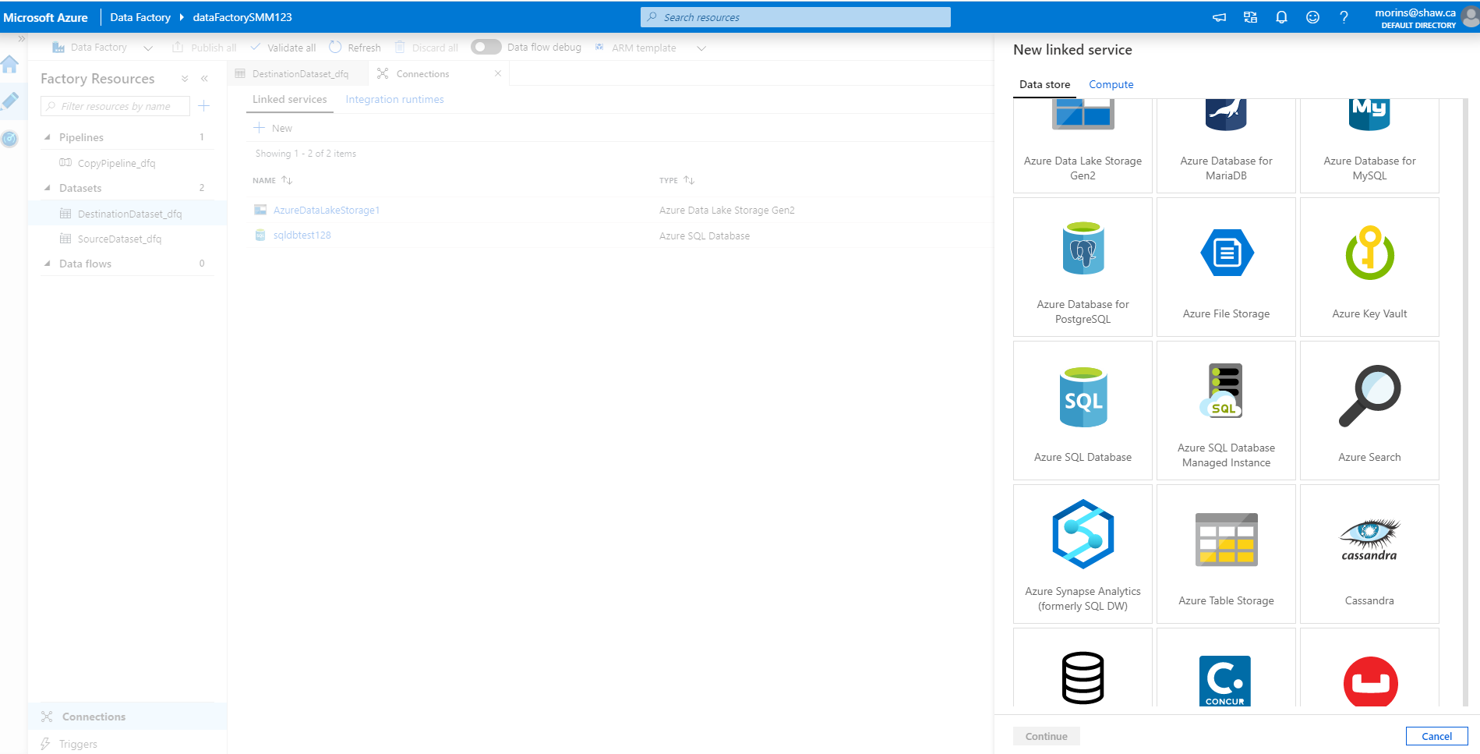

Fill in details of the Azure SQL DB linked service:

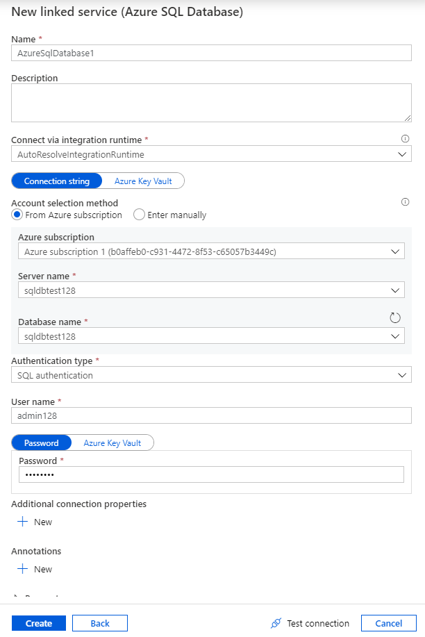

The newly created service will appear in the list of Linked Services:

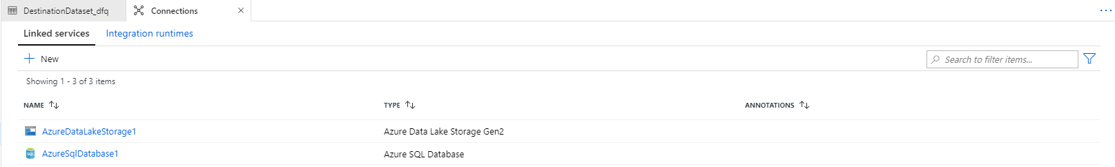

Click on the code for the linked service to confirm that the password has been encrypted:

